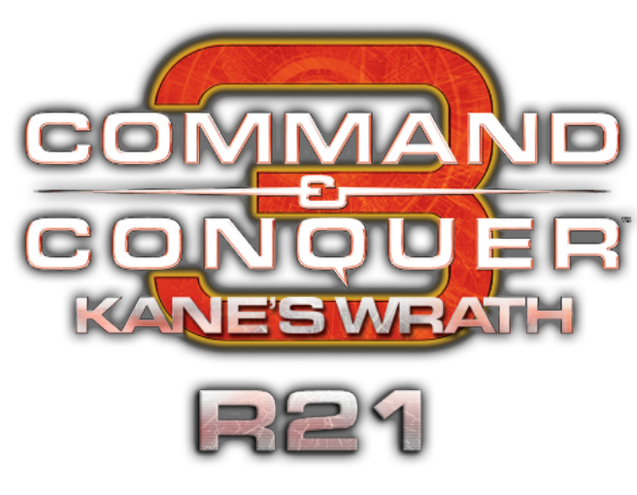

**R21e Change Log**

* Firehawks, Mechapedes, Flame Tanks, and ZOCOM Orcas can now destroy friendly husks if force-fired.
* Corruptors and Toxin Mechapedes now heal allied Annihilator Tripod and Reaper Tripod husks.
* Mechapedes now follow rally points set at the Warp Sphere and Warp Chasm as before.
* The bug where Engineers/Saboteurs and Assimilators die through structure geometry while capturing has been fixed.
* Engineers/Saboteurs and Assimilators now play the correct sound for capturing and repairing structures.
* The Hammerhead target cursor against aircraft now only works with anti-aircraft infantry garrisoned inside.
* A Harvester inconsistency has been fixed with Black Hand, Scrin, Traveler-59, and Reaper-17 Harvesters.
* The Avatar and Purifier husk now display the correct texture on a equipped flame tank.
* Fixed a bug where Nod harvesters don't display any contained Tiberium while harvesting Blue Tiberium.
* Upgrade models have been removed for the building placement cursor on the GDI airfield, Nod Tech Lab, Nod Hangar, and Nod Operations Center.
* Tiberium Vein Detonation has been reworked and now uses the EA implementation for only applying damage to units within the radius. The vein detonation damage begins after 3.5 seconds and deals 80 damage per update, increased from 60. The final detonation damage remains the same.
* Bridge segments on the map "Battlebase Beaverton" no longer show health bars.
* Christmas themed maps made by Zypherbullet have been added to the 1v1 map pack and are located in the in-game lobby by searching for the [R21 Xmas] prefix.
* The following maps have been adjusted: Smashed Dustbowl (remake), Tournament Savannah, Tournament Odyssey Redzone, Tournament Towerless and Tournament Oasis.

**R21d Change Log**

* A 0.25s delay has been added to the Prodigy/Mastermind 'Teleport Units' ability after units have been selected to prevent this ability from failing.
* The Awakened and The Enlightened can now be repaired by repair drones. The repair rate on these units has been adjusted for balance.
* The "EMP Strike" ability found on the EMP Control Station now functions correctly on shielded Devastator Warships and Planetary Assault Carriers.
* The Drone Ship locomotor has been adjusted so rotation appears smoother.
* Phase Field and the Mastermind/Prodigy "Teleport Units" ability will no longer work on units affected by the Redeemer's "Rage Generator" ability.
* Scrin faction Storm Columns will now spawn a Buzzer when sold off.
* A bug where decoy Attack Bikes inflict real damage has been fixed.
* The Devourer Tank and Reaper Tripod "Conversion Beam" ability reload time has been reduced from 10s to 3s as a workaround for the occasional bug where charging fails.
* Warfactories can once again use their ability to repair aircraft.
* An issue which caused Harvesters harvesting Blue Tiberium to display Green Tiberium has been fixed.
* A serious game breaking exploit has been fixed without giving more details.
* The maps "Tournament Oasis" and "Smashed Dustbowl Redzone" have been added to the map pack. Full credit goes to DesolatorTrooper for making these maps.
* The following maps have been added to the ranked map pool: "Tournament Oasis", "Smashed Dustbowl Redzone" and "Tournament Savannah".
* The Blue Tiberium Field on the map "Tournament Savannah" now grows at a slower rate.

**Global Changes**

* The delay before Surveyors and Emissary's spawn has been removed.
* The GDI, Nod Construction Yard and Scrin Drone Platform pack time has been adjusted to be more inline with the animation frames, this should make packing them up and moving afterwards more responsive.
* Allies can now build around Outposts.
* Expansion Point ground control radius increased from 200 to 275.
* Defensive Tower vision range increased from 400 to 525 to match weapon range.
* Harvester geometry changed to fix a bug where Harvesters get stuck at the entrance on other Harvesters.
* More area around the player spawns on Redzone Rampage can grow Tiberium.
* Emissary, Surveyor and Explorer cost reduced from 1500$ to 1400$.
* On the map Tournament Odyssey it is no longer possible to hide units in the edges of the map.
* Garrisoned units no longer shoot whilst trapped in a Stasis Shield.
* The installer will now install language files correctly.

**GDI/Nod faction Harvesters will now spawn either a Green or Blue Tiberium Crystal on death depending on the following conditions:**

* If two or more of the Tiberium bars display Blue Tiberium it will spawn a Blue Tiberium Crystal.
* If the Harvester has one Blue Tiberium bar a Green Tiberium Crystal will spawn.
* If the Harvester contains only Green Tiberium it will spawn a Green Tiberium Crystal.
* Harvesters containing no Tiberium will not spawn any crystal.

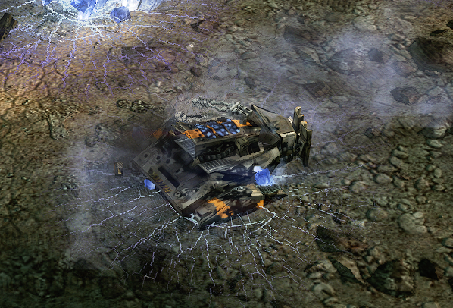

**GDI Global**

* Sniper Team reliability vs fast moving targets has been improved.
* Grenadier projectile speed increased from 180 to 220.
* EMP Grenade delay increased from 0.45s to 0.75s.
* Ion Cannon beam stage damage increased from 1500 to 2500 allowing it to destroy fenced tier 3 and health equivalent buildings.

**Nod Global**

* Nod Support Airfield geometry adjusted so it doesn't occupy as much space.
* Shadow Team range increased from 225 to 240.
* Fixed Beam Cannons not unstealthing when shooting under a Disruption Tower.
* Reckoner Dozer Blades increased from +25% to 30%. Dozer Blade Scorpion Tank rocket armor reduced from +25% to +20%.
* Nod Turret Hub geometry reduced so its hitbox represents its actual size.
* Vertigo anti air damage increased from 55 to 60.
* The Redeemer rocket garrison now has a clip size of 3 but its anti air damage scaler has been reduced from +200% to +135%.
* Tiberium Core Missile Attack Bikes have a 180% damage bonus against Orcas and Venoms instead of 200%, allowing both to survive one shot.
* Venoms will now de-stealth when using the “Reflector Beam” ability under a Disruption Tower.
* Shadow Teams no longer shoot vehicles or structures.

**Nod**

* Nod Confessor leaders now get the Tiberium Infusion +10% health bonus.
* Charged Particle Beam upgrade has been added back to Nod Confessors in the rare instance it happens in a team match.

**Marked of Kane**

* Tiberium Trooper hp increased from 350 to 400.
* Tiberium Trooper movement speed increased from 45 to 55 without upgrade (to match the Black Hand Squad), speed with upgrade remains the same.
* Redeemer Tiberium Trooper hardpoint range increased from 250 to 275.
* Marked of Kane Tiberium Infusion upgrade cost reduced from 1000$ to 500$, upgrade duration remains the same, at 30s.
* Awakened EMP duration reverted to 5s and a 1s delay has been added before EMP can be used from the Hand of Nod or from sold off structures.

**Scrin Global**

* The Mastermind and Prodigy Manipulator Device ability now gets canceled if the targeted structure is sold off or destroyed during the 1 second delay.
* Shock Trooper pre disc damage increased from 75 to 83.
* Eradicator Hexapod allied infantry buff adjusted so it consistently gives +25% additional armor.
* The Wormhole has been tweaked so units may enter it easier.
* Infestation Hive cost reduced from 1000$ to 800$.
* Eradicator Hexapod Ravager hardpoint pre attack delay reduced from 0.7s to 0.4s, reload time increased from 1.5s to 1.8s.
* Mechapede stealth detection range increased from 100 to 125.
* PAC damage vs Stealth Tanks reduced by 25%.
* Gun/Shardwalker have a slightly increased firing arc.
* Phased units while EMP’d no longer remain phased permanently - thanks to a discovery made by Firehawk-Ph4ntom.
* Phase Field duration increased from 30s to 35s.
* The Mastermind/Prodigy bug where the “Teleport Units” ability fails has been fixed.
* Units can no longer be teleported from within a Stasis Shield.
* Stormriders no longer deal 25% less damage vs Gunwalkers/Shard Walkers.
* Units such as the Mechapede will no longer get trapped inside a Stasis Shield from the outside.
* The Drone Ship now deploys 0.5s faster to match the un-deploy time.

**Traveler-59**

* Traveler-59 Wormhole cooldown increased from 120s to 180s.

**Visual and Sound Changes**

* Fixed the Zone Trooper jump jet mesh occasionally showing .
* Shredder Turret muzzle flash has been removed from the preview cursor.
* The Titan, Battlebase, MARV and Guardian Cannon with railguns now display railgun distortion fx.
* The GDI Construction Yard pack animation no longer clips.
* The Redeemer and Purifier will use their own death sounds, not the Avatar ones.
* GDI Refineries no longer show Tiberium bars after deploying.
* Space Command Uplink steam fx added to non 4k mod version, and the Sonic Emitter firing fx is now larger.
* The ZOCOM Harvester now displays the correct formation preview.
* The Plasma Missile Battery no longer uses the Rift Generator texture when deploying.
* GDI/Nod faction Harvesters now display the type of Tiberium they’ve harvested. Smoke fx, textures and other particle effects have been added for when Blue Tiberium is harvested. Scrin Harvesters also display unique effects when harvesting Blue Tiberium.
* The Steel Talons Titan now displays Adaptive Armor when both it and Railgun Accelerator’s are active.

